Java JDK Part 1: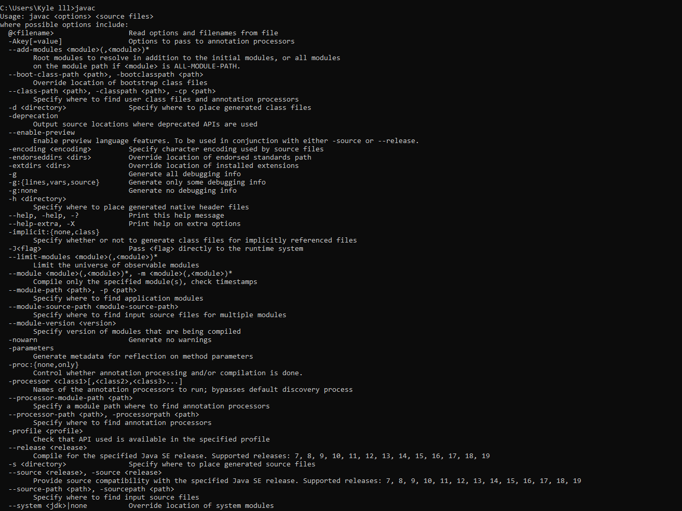

Java JDK Part 2:

